[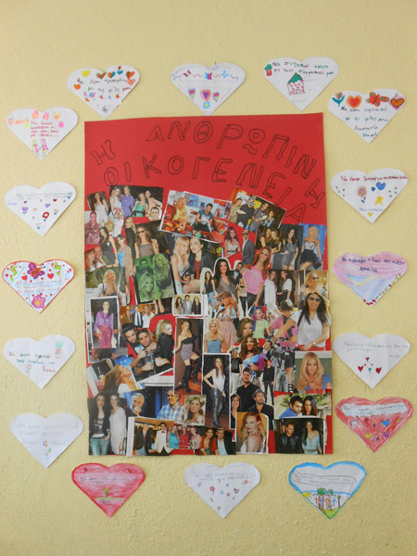](http://8dim-evosm.thess.sch.gr/wp-content/uploads/2016/01/anthropini-oikogeneia1-new.jpg)[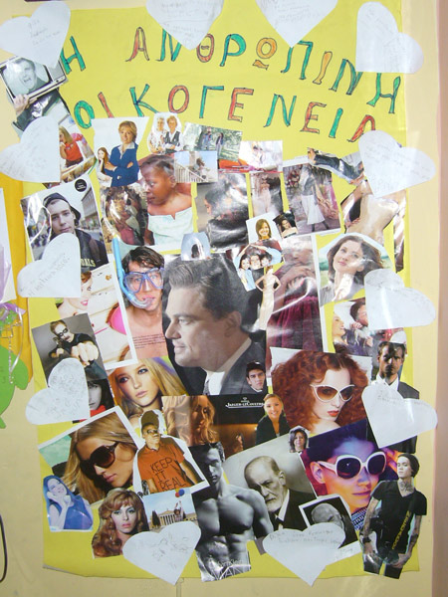](http://8dim-evosm.thess.sch.gr/wp-content/uploads/2016/01/anthropini-oikogeneia2.jpg)

Ανθρώπινη Οικογένεια

[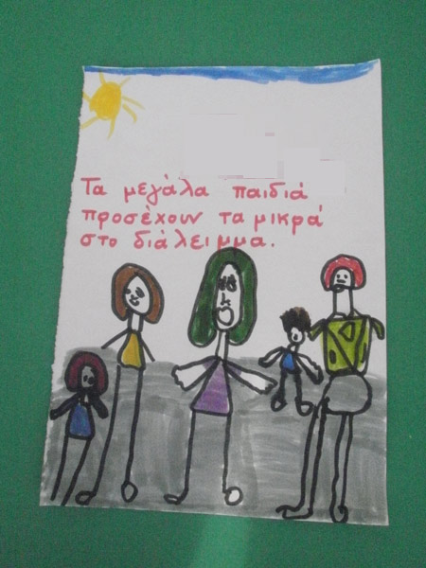](http://8dim-evosm.thess.sch.gr/wp-content/uploads/2016/01/asfales_sxoleio2-new.jpg)[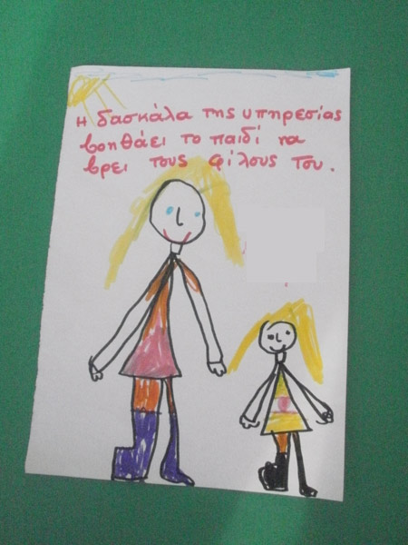](http://8dim-evosm.thess.sch.gr/wp-content/uploads/2016/01/asfales_sxoleio1-new.jpg)

Ασφαλές Σχολείο