[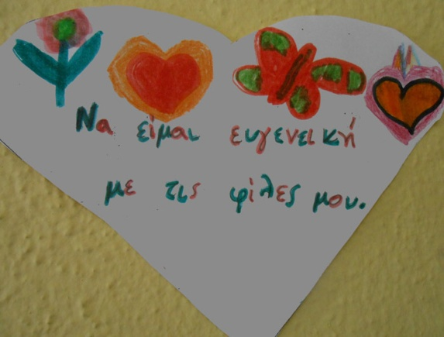](http://8dim-evosm.thess.sch.gr/wp-content/uploads/2016/01/armoniki-siniparksi-2.jpg)[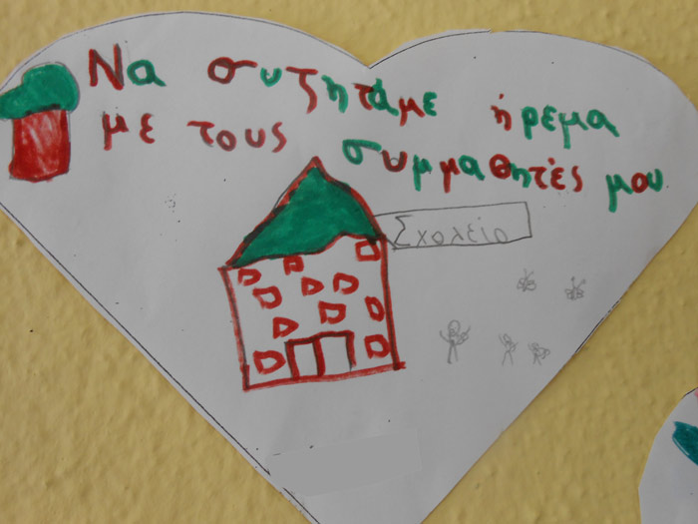](http://8dim-evosm.thess.sch.gr/wp-content/uploads/2016/01/armoniki-siniparksi-3.jpg)

[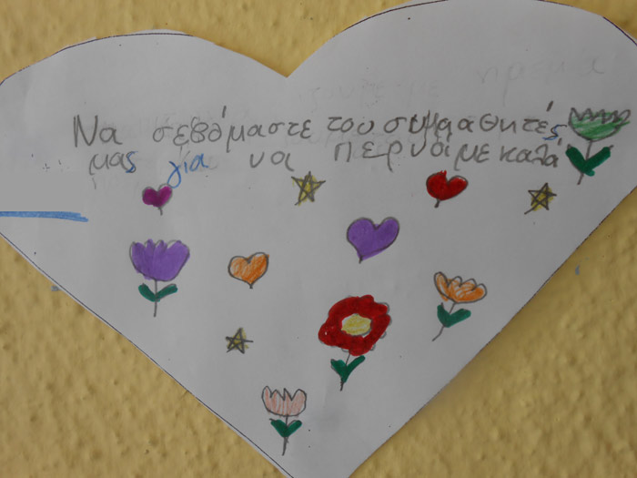](http://8dim-evosm.thess.sch.gr/wp-content/uploads/2016/01/armoniki-siniparksi-4.jpg)[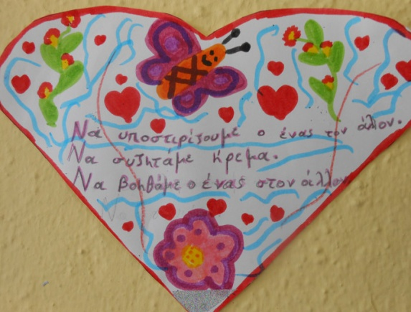](http://8dim-evosm.thess.sch.gr/wp-content/uploads/2016/01/armoniki-siniparksi-5.jpg)

[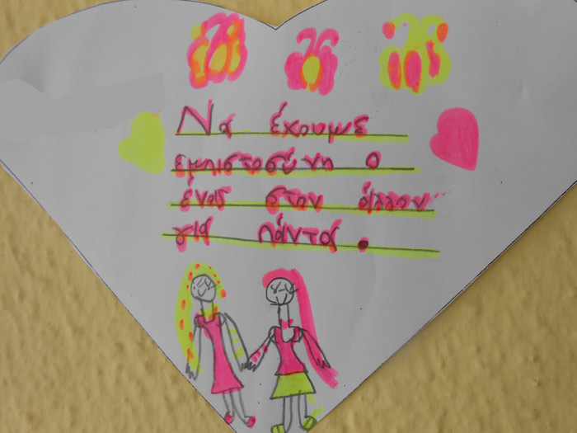](http://8dim-evosm.thess.sch.gr/wp-content/uploads/2016/01/armoniki-siniparksi-6.jpg)[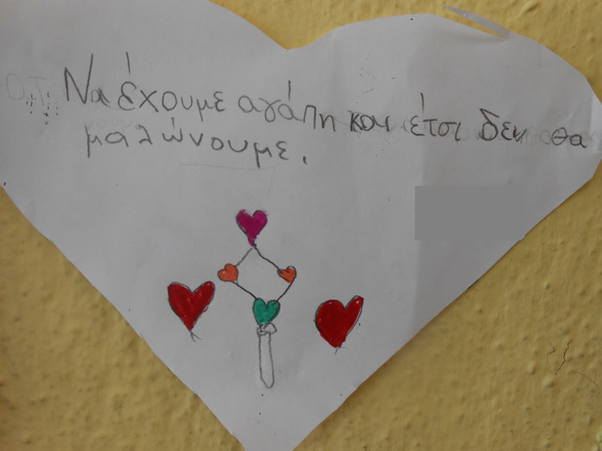](http://8dim-evosm.thess.sch.gr/wp-content/uploads/2016/01/armoniki-siniparksi-7.jpg)

Αρμονική Συνύπαρξη

[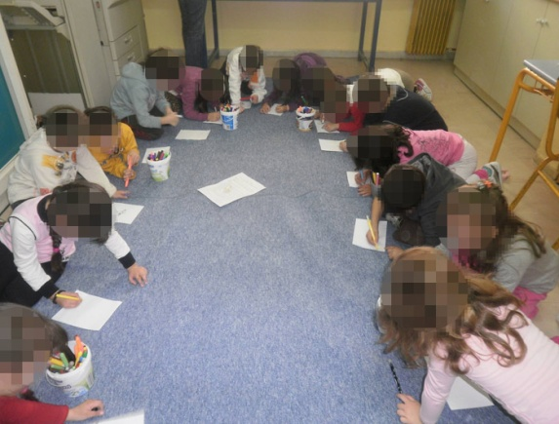](http://8dim-evosm.thess.sch.gr/wp-content/uploads/2016/01/magikos-kiklos-1.jpg)[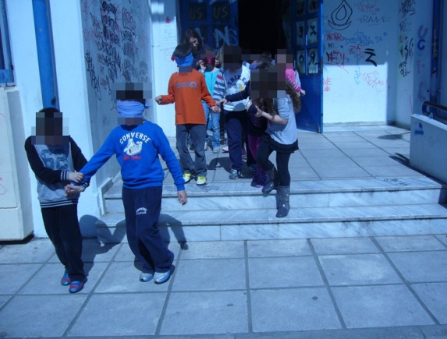](http://8dim-evosm.thess.sch.gr/wp-content/uploads/2016/01/empistosini-simmathiti-1.jpg)

Ο Μαγικός Κύκλος και Άσκηση Εμπιστοσύνης στον Οδηγό Συμμαθητή